**Mr. Visca’s: Calculus (Chpt 2.1)**

**Chpt 2 – Day 2 Properties of Limits**

**Definition of a Limit**

def: _________________________________________________

_________________________________________________

It's read: _______________________________________________

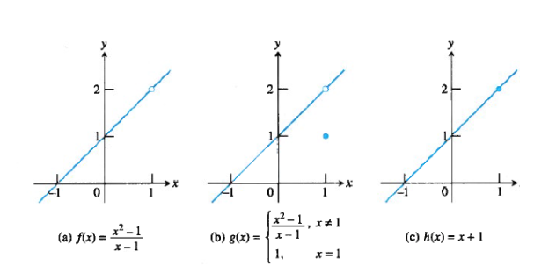



**Properties of a Limits**

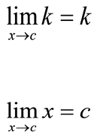

**_________________________________________________**

_________________________________________________

if L, M, c, and k are real numbers

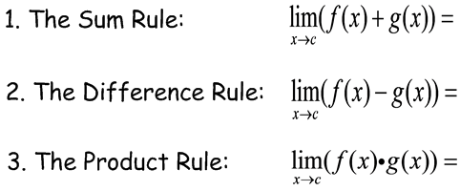

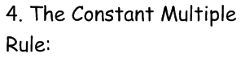

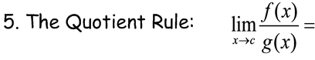

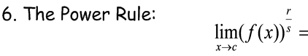

Use the properties of limits to find the limit:

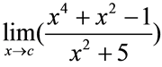



**Theorem 2 -- substitution theorem**



Find the limit of the following:

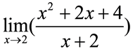

*HW: Sec 2.1 #s 7 - 14*